Erasmus+ Capacity Building projects
in the field of Higher Education
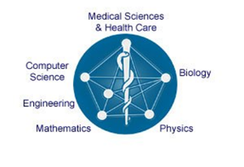
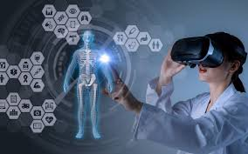
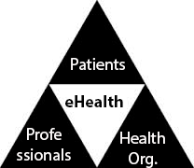
ICU
Knowledge triangle, Innovation,
Reinforcing of Education, Research,
609506-EPP-1-2019-1-SE-EPPKA2-CBHE-JP E-Health and Medical Links
Editors in Chief:

Dr.Mosad Zineldin
Dr.Valentina Vasicheva

Editorial board:

Dr.Safaa ELMeneza
Dr. Essam Elkordi
Dr. Samy Ghoneimy
Dr. Ahmed Sharaf
Dr. Taysir H. Soliman

Project Executive Manager
Dr.Mosad Zineldin
Professor, Health Sciences
Office K2: 2235A .+46 (0)705 502186 , + 46 470 708798
Faculty of Health & Life Sciences-Dep. Medicine & Optometr

Grant holder:
Linnaeus University- SE-35195 Växjö -Sweden

Partner institutions:
- Linnaeus University
- University of Genoa
- CESIE
- Institut für den Donauraum und Mitteleuropa
- Tallinn University of technology
- Notre Dame University
- Lebanese University
- Beirut Arab University
- Modern University of Business & Sciences
- Alexandria University
- British University in Egypt
- October 6 University
- Badr University in Cairo
- AL -Azhar University
- University of Sinai
- Assiut University
- International of Applied Science &Technology
- LEAD health care consultancy

Table of contents | Page
Project objectives | 3
Kick off meeting | 3
E learning | 3
E health | 4
M health | 4
Why Health Information Technology? | 5
Photo Gallery | 6
Biography | 7

Project Objectives:

Specific objectives

To establish the international network Centers of e-health Innovations in EG and LB for administrative and technical supporting of e-health research/ consulting / training activities.

- To develop the Knowledge Triangle, innovation: Education-Research- e-health business web platform KTERE for collaboration in development and commercialization of e-Health innovative technologies and tools.
- To develop a new integrated professional short term (6 months) and long term (one year) diploma program in Medical informatics and e-Health (6 basic modules) for partner universities in LE and EG.
- To develop in-service lifelong learning training (LLT) program (4 modules) in the area of e-health innovative Medical/health/IT/engineering. To develop on site and distance in-service training program (4 modules) in the area of innovative E-health for the further utilization of OER (open educational resources) and rich open learning environments.

Kick off meeting
The meeting was conducted on 10-11 February, 2020 and was hosted by October 6 City, Cairo, Egypt.
The first day of the Kick-off meeting was dedicated to the presentations from the grant holder and participating Universities as well as partner country institutions. Administrative management of the project and duties of the steering committee was discussed and agreed upon.
The second day started by continuation of the presentation by partner Universities .Then the discussion in details of the work packages and the leader of each package as well as co-leaders as was suggested by prof. Mosad Zineldin (LNU) was completed.
Online lecture by a colleague from LNU/the grant holder university was also given.
The participants agreed on the distribution of work packages and steering committee.

E-learning:

E- learning is system of learning based on formalized teaching that used help of electronic resources in or out of the classrooms. It is network assisted transfer of skills and knowledge, and transfer of education through to large number of students at same time or different times. Although it was not initially widely accepted due to lack of human elements, plagiarism or cheating, no self-discipline, no face-to-face interaction, Lack of flexibility, Lack of input from trainers, Slow evolution and Lack of transformational power. Recently it is becoming popular and accepted all over the world. Modern learner management system is capable of overcoming these disadvantages. The learning styles and changes in students’ needs have been changed, allowed the implementation of E learning in diversity of education system. Also the improvement of in e-learning facilities and to implement human factors support the use of e-leaning. E –learning, when being available all days through the internet, encourage students from different age and grade to continue their education and improve their performance. e-Learning is an efficient way to learn, it is cheap with an excellent return on investment, several studies showed that students may perform better with training retention rates are higher. Also according to open University it is attractive to environmentally-friendly users (green way). Most important, it allows for self-paced learning that suits medical students and help long life learning.

e-learning delivery modes include several element as web-based learning, computer-based training, CD-ROM based learning, webinars, virtual classroom, mobile Learning, video-based learning, collaborative learning, custom eLearning, micro learning, these allowed course developer to choose the suitable tool for the teaching material.

e- learning is more than just slides and lectures. It must address the real learner needs. Developing a really effective e-learning course takes time, money, and a great amount of expertise. A good e-Learning course involves multimedia, custom web development, technical support, and strong User Interaction design.
In this project we will use the best practices for e-learning courses known by the participating Universities.

E Health
It is the technology that supports the functions and delivery of healthcare, e-health is term for healthcare practice supported by electronic processes and communication, dating back to 1999. Some would argue it is interchangeable with HIT, while others use it in the narrower sense of healthcare practice using the Internet. It is the technology of use of information and communication technology for health.
Application of E Health will facilitate efficient and high quality care delivery, people-centered and continues care, as well as proactive and preventive care.
m-Health
Mobile eHealth or m Health broadly encompasses the use of mobile telecommunication as IPhones, network and multimedia technologies as they are integrated within mobile and wireless health care delivery systems for better healthcare.

The m-Health field promotes a better health information communication & delivery, to reach areas, people, and/or healthcare practitioners with limited exposure to certain aspects of healthcare.

M Health, Technology rests on providing healthcare access.

It is suggested that there are seven application categories within the m Health field:
- Education and awareness
- Helpline
- Diagnostic and treatment support
- Communication and training for healthcare workers
- improves decision-making by health professionals (and patients)
- Disease and epidemic outbreak tracking
- Remote monitoring, Remote data collection
Why Health Information Technology?
Health Informatics is an important domain of global competition that reaches across the social, economic and political realms. Health IT professionals play a critical role in improving the quality of health care by preventing errors and increasing efficiencies through technology.

-Improve health care quality as it:
  - Expand access to affordable care
  - Reduce duplication and fill in gaps that lead to better care as well as individual patient care and improve operating efficiency
  - Much of the evidence on QI were related to primary and secondary preventive care as early detection of, infectious disease, early detection of outbreaks, identification of high-risk patients, improved tracking of chronic disease management
  - Improve safety, prevent and reduce medical and medication errors
- Improved monitoring of drug usage, and study of effectiveness. This leads to the reduction of adverse drug interactions while promoting more appropriate pharmaceutical utilization.
- Enhances information integrity, reduces transcription errors.

-It also reduce health care costs, and increase financial effectiveness
-Increase administrative efficiencies
-Decrease paperwork
-Enhance the knowledge of parents/families and their effective involvement in their children's health care

Photo Gallery
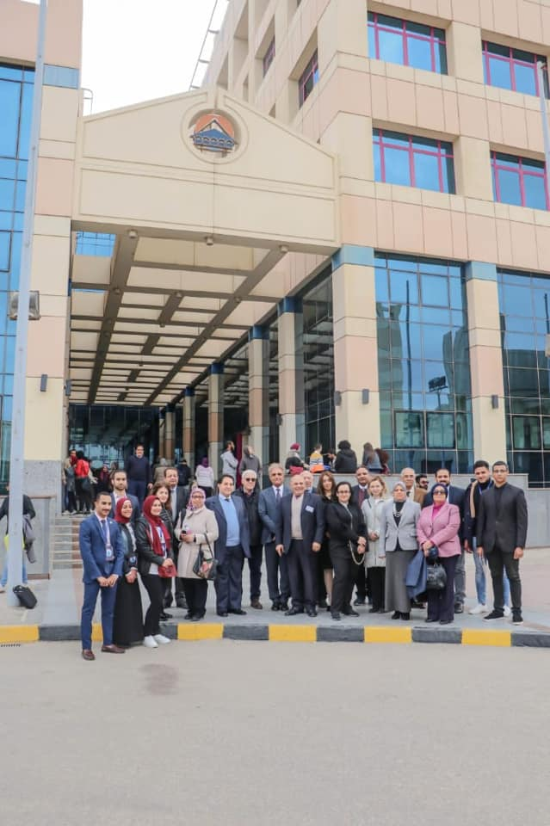
Kick off meeting, February/ 10/ 2020, all the participants

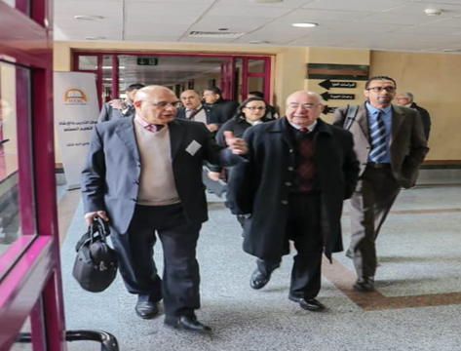
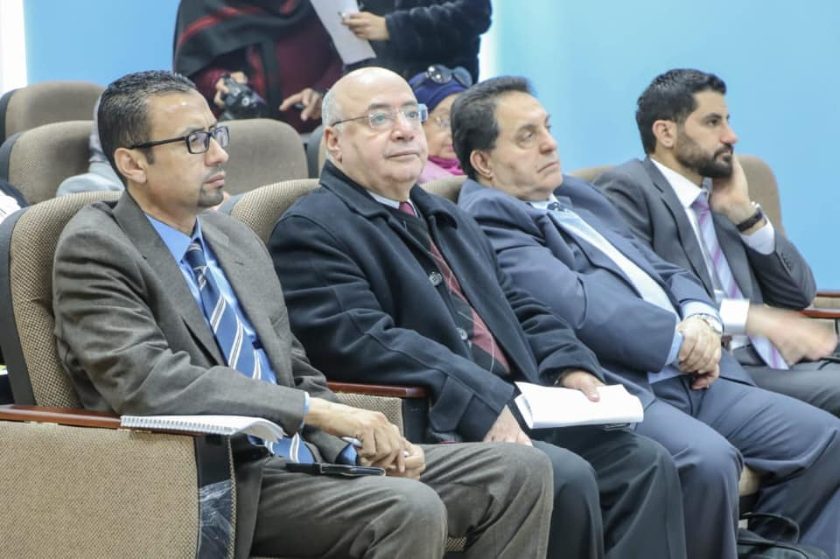
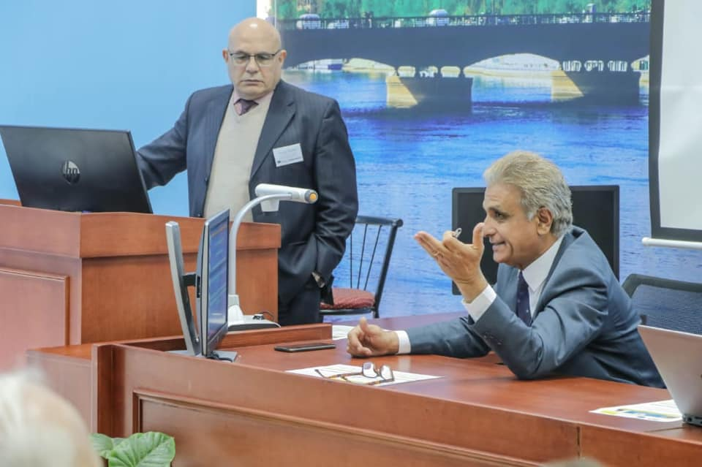
Dr. Mosad Zineldin Dr. Valentina Vasicheva

Dr. Mostafa Kamal
Biography
Dr. Mosad Zineldin
ICU-RERE Project manager, representing the grant holder University – Linnaeus University- Sweden.
Professor at the Faculty of Health and Life Sciences, Dep. of Medicine and Optometry.
Dr. Mosad Zineldin is a full Professor with multidisciplinary scientific doctoral and master degrees focused on health sciences but also includes other different areas: Main research interest is developing new approaches to reduce surgery, medical and medication errors related to spinal arteriovenous malformations (AVMs) and Brain AVMs Surgery, Medicine and eHealth Is also another area of recent research interest in addition to the following:

• Cognitive and Behavioural Neuroscience and psychology
• Clinical Neuroscience and Psychology
• Psychiatry
• Sexology
• Social psychology and psychiatry
• Quality, Management, Economics, relations, interaction & networks

Editor in Chief. Associate and Guest editor of several International Journal such as:
• The International Journal of Environmental Research and Public Health—IJERPH.
• BIOMedical Central- BMC Health Services Research
• Int. J. of Work Organization and Emotion
• International Journal of Psych-MDPI

Dr. Safaa ELMeneza
ICU-RERE contact site, AL-Azhar University
Professor of pediatrics /neonatology, Faculty of Medicine for Girls, AL-Azhar University.
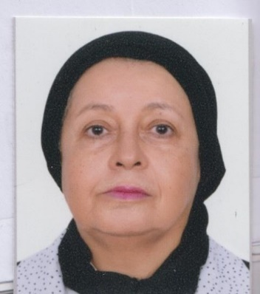
Dr. Safaa ELMeneza is a Professor with MS, MD Paediatrics, Diploma TQM, DGSHH, DHPE. Main research area focused on neonatology, neonatal intensive care, neonatal infection and perinatal asphyxia, patient safety, medical education and quality of health care. Interested in global health, e-learning, e-health and health informatics.
Also interested in:
• Neonatal neurology
• Life support
• Mechanical ventilation
• Networks

PI of the successful project neonatal safety training network and sustainability of neonatal safety training network. Participated in international multicenter RESAIR II study.
Reviewer in Acta Paediatrics, Merit research journal of Medicine and Medical sciences (MRJMMS), Pediatrics & Neonatal Biology Open Access and BMC Paediatrics, Advisory Board for Journal of Recent Advances in Medicine (JRAM) website.
Editor several J such as:
• Asploro Journal of Pediatrics and Child Health
• Journal of Neonatal Research and Pediatrics Care
• Madridge Journal of Case reports & Studies
• Acta scientific Paediatrics
• Journal of Neonatal Biology
• Journal of Neonatology and clinical pediatrics

